PROJECT REPORT

1.INTRODUCTION

* 1. Overview

ChatConnect-A Real-Time Chat And Communication

Project Discription:

* Real-Time Chat is powered by Socket.IO. is **a web application that allows multiple users to have a private and public chat**. This app allows one to one chat online and its fast and easy to use. Please note that the application code is written in Javascript ES6.
* Real-Time Chat is powered by Socket.IO. is a web **application that allows multiple users to have a private and public chat**. This app allows one to one chat ...
* This project is for the development of a chat system based on Javascript programming language and network concept. The app allows people to **transmit messages** ...
* Chatting app **allows you to communicate with your customers in web chat rooms**. It enables you to send and receive messages. Chatting apps make it easier, simpler, and faster to connect with everyone and it is also easy to use. There are many types of chatting apps and every one has its own format, design, and functions.

1.2 Purpose

* An android application to provide users' a hassle free chatting experience while maintaining the users' privacy through end-to-end encryption.
* Chat apps **can let users know if a child needs to be picked up or if a dinner location has been changed**. The Android framework lets messaging apps extend ...

* A chat application **makes it easy to communicate with people anywhere in the world by sending and receiving messages in real time**. With a web or mobile chat app, ...
* Learn why and how building chat apps boost the scope of your business with NectarBits - a mobile application development. Read this guide to know more.

1. Problem Definition & Design Thinking

2.1 Empathy map:

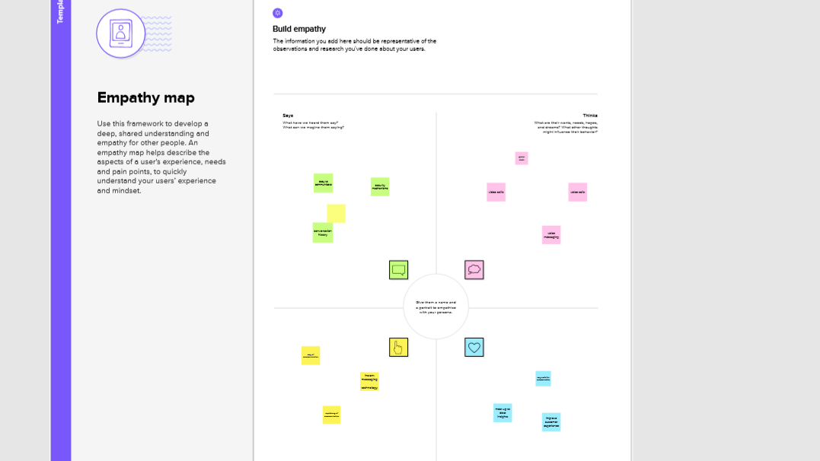

2.2 Ideation & Brain storming:

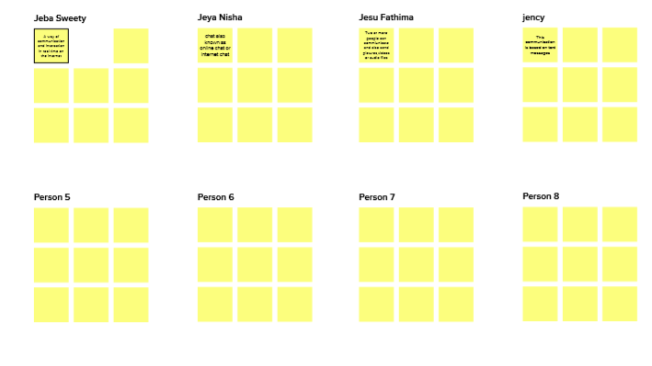

1. Result

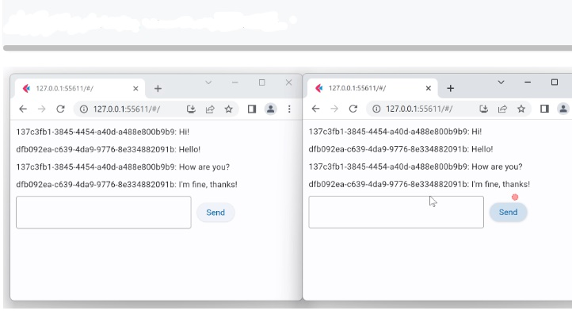

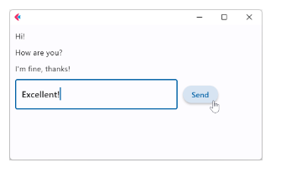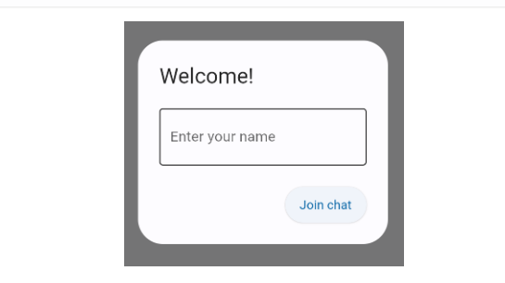

4 ADVANTAGES & **DISADVANTAGES**

Advantages:

* Obviously chat is easy to reach for your customers, but what’s more is that the average resolution time is significantly lower than with traditional service channels. [It takes less than a minute](https://techjury.net/stats-about/live-chat/)to resolve a customer issue using live chat.
* One of the handy advantages of live chat is the option to see a real-time preview of what the customer is typing before she hits enter. It gives your chat agent the chance to think about a solution, research and impress users with prompt, customized answers.
* A chat application **makes it easy to communicate with people anywhere in the world by sending and receiving messages in real time**. With a web or mobile chat app, users are able to receive the same engaging and lively interactions through custom messaging features, just as they would in person.

Disadvantages:

* You can't be sure other people are being honest or that they are who they say they
* If you are feeling vulnerable, people online might try to take advantage of you.
* Building relationships online can result in your spending less time with friends and family.

5 APPLICATION

* A chat application **makes it easy to communicate with people anywhere in the world by sending and receiving messages in real time**. With a web or mobile chat app, users are able to receive the same engaging and lively interactions through custom messaging features, just as they would in person.

* Examples of real-time software include **aircraft navigation programs, multimedia broadcasts, multi-player video games, data analysis programs and stock-trading applications**.
* A React **real**-**time chat** where users can **chat** anonymously with others and also can **chat** with others privately and get unread private messages from others. reactjs ...

6 CONCLUSION

* The main objective of the project is to develop a Secure **Chat Application**. I had taken a wide range of literature review in order to achieve all ...
* This research paper contains that **chat app** should be a **real**-**time** forum and multi-site for use by many users. The programming language used to build the Node.js ...

7 FEATURE SCOPE

* Comparison Table of Top Chatting Apps.
* WhatsApp.
* Facebook Messenger.
* video conferencing.
* voice over Internet Protocol.
* some e-commerce applications.
* instant messaging (IM) applications.
* real-time operating system, or RTOS.

1. APPENDIX

A.Sourcecode:

